Class I Maths – 19th August 2019:
1. Which among these is longer?
A train with one engine and 12 bogies
OR
the other with one engine and 7 bogies and by how many?
______________________________________________
18. i. 6 + 6 + 6 + 6 = _______
ii. 5 +6 + 6 + 6 = _____ __
**********************************************
Class II Maths – 19th August 2019:
1. Complete the series
i. 63, 65, ____, 69, ____.

ii. 80, ____, _____, 74, 72.

2. Fill in the missing numbers:
i. 30 + ________ = 39.
ii 100 – 100 = _______
**********************************************
Class III Maths – 19th August 2019:
1. Which is heavier 5 Kgs of paper or 5 Kgs of rice?:
i. paper [ ] ii. Rice [ ]
iii. paper and rice are of the same weight [ ]
ii. In a library there are 2500 books 1200 are new books how many are old? ____
2. i. How many in a dozen? ____________
ii. Arrange in an ascending order
600, 950, 625, 590, 526, 160, 610
___________________________________________
*********************************************
Class IV Maths – 19th August 2019:
1. How many 1000’s, 100’s, 10’s and 1’s should be added to give the largest 4 digit number?
a. 9,9,9,9 [ ] b. 1,1,1,1 [ ]
c.1,0,0,0 [ ] d. 9,0,9,9 [ ]
2. Which of these is same as 28 + 6 + 4?
a. 25 + 6 + 4 [ ] b. 31 + 7 [ ]
c. 286 + 4 [ ] d. 2 + 86 + 4 [ ]
Class V Maths – 19th August 2019:
1. i. How many leap years from 2020 to 2060?
________________________________
ii. How many sheets make a quire of machine-made
paper? ____________________
2. Write the following in descending order:-
i. 9106, 9611, 9116, 9161, 9961 _______________________________________
ii. XXVIII, XXX, VII, CXX : _________________________________________
**********************************************
Class VI Maths – 19th August 2019:
1. Here are a few numbers: 5760, 1080, 720, 2160, 1440. Identify the number that is not the divisor of any of the given numbers?
a. 23 [ ] b. 24 [ ] c. 36 [ ]d. 12 [ ]
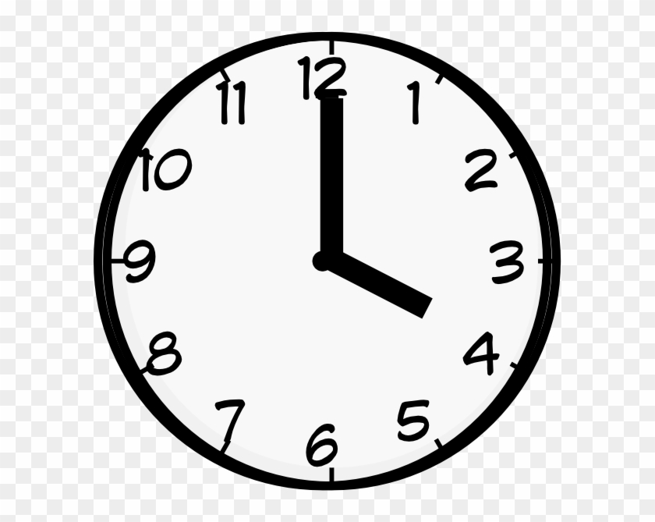

2. The time shown on the face of a clock is 4 o’ clock?
Through how many degrees will the hour hand move in 10 hours?
a. 360⁰ [ ] b. 300⁰ [ ] c. 340⁰[ ] d. 345⁰ [ ]
****************************************************
Class VII Maths – 19th August 2019:
1. Mitali bought 6 pens. The cost of each pen was between Rs 25 and Rs. 30. Which of these could be the total cost of the pens?
a. Rs 55 [ ] b. Rs. 126 [ ]
c. Rs 173 [ ] d. Rs. 330 [ ]
2. Supply the missing number to make this number statement true:-
1024 + 1025 + _______ = 1025 + 1025 + 1025
a. 1024 [ ] b. 1025 [ ] c. 1026 [ ] d. 5124 [ ]
****************************************************

Class VIII Maths – 19th August 2019:
1. The fractions(⁴/ ₁₄) and ( ? / ₂₁)are equivalent fractions. What number is in the numerator marked with ?
a. 6 [ ] b. 7 [ ] c. 11 [ ] d. 14 [ ]
2. Which of the following is the same as (³/ ₁₀)of 50
a. 3% of 50 [ ] b. 6 % of 100 [ ]
c. 30% of 50 [ ] d. 60% of 100 [ ]
****************************************************
Class IX Maths – 19th August 2019:
1. A shopkeeper buys a number of books for Rs 80/- If he had bought 4 more books for the same amount each book would have cost 1 rupee less. How many books did he buy?
a. 16 [ ] b. 20 [ ] c. 18 [ ] d. 22 [ ]
2. A shopkeeper sold an air conditioner for Rs. 25935 with a discount of 9% and earned a profit of 3.74% what would have been the percentage profit if no discount were offered?
a. 12.3% [ ] b. 15.6% [ ]
c. 16% [ ] d. none of these [ ]
***************************************************
Class X Maths – 19th August 2019:
1. One morning after sunrise, Suresh was standing facing a pole. The shadow of the pole fell exactly to his right. To which direction was he facing?

a. East [ ] b West [ ] c. South [ ] d. North [ ]

2. A man walks 5 km toward south and then turns to the right. After walking 3 km he turns to the left and walks 4 km. And then he goes back 10 km straight. Now in which direction is he from the starting place ?

a. South East [ ] b North West [ ] c. South [ ] d. West [ ]
**********************************************************
Class XI Maths – 19th August 2019:
1. What is the average run rate made by a player if he hits 6 sixes and 8 fours in 24 balls
i. 1.5625 [ ] ii. 2.8333 [ ] iii. 3. 25 [ ] iv. 3.9 [ ]
2. If there are 888888bicycles distributed in 888 rural schools of a district, how many bicycles will each school get?
i. 1111 [ ] ii. 1001 [ ] iii. 3. 1077 [ ] iv. 1000 [ ]
****************************************************
Class XII Maths – 19th August 2019:
1. If a student received a score of 85% on a test in which he got six questions wrong, how many questions were on the test?
i. 5 [ ] ii. 40 [ ] iii. 90 [ ] iv. 510 [ ]
2. If the measures of the angles of a triangle can be represented by x +5, 3x-75 and 2x-30, what kind of triangle must it be ?
i. Right [ ] ii. Equilateral [ ]
iii. Obtuse[ ] iv. Scalene [ ]
*********************************************

